# **NHS App guidance**

## **How to access the NHS App**

### Who Can Use the NHS App

* **Age Requirement:** You must be **13 years or older** to register for the NHS App.
  + If you're aged 13 to 15, you’ll need to contact your GP surgery for access to GP online services before you can use the NHS App.
* **Location:** You need to be registered with a GP surgery in England or the Isle of Man.
* **NHS Login**: You’ll need to set up an NHS login and verify your identity to access full features.
* While you’re registered with Defence Medical Services, you cannot use the NHS App.

### How to set up the NHS App

1. **Download the App or open the website** 
   * + - To get the NHS App, you need to download it from the [App Store](https://www.apple.com/uk/app-store/) (for Apple devices) or [Google Play](https://play.google.com/store/apps/details?id=com.nhs.online.nhsonline) (for Android).
       - Alternatively, you can access the same services through the NHS website - <https://www.nhsapp.service.nhs.uk/login>
2. **Create an NHS Login**

* Follow the prompts to create and account. You’ll need:
  + An email address
  + Mobile phone number
  + Postcode
  + Date of birth
  + Your NHS number (if you know it)

1. **Prove Your Identity with photo ID**
   * You’ll need to verify who you are to access full features:
     + Upload a photo of a valid photo ID (e.g. passport or driving licence).
     + Record a short video of your face for facial recognition.
   * If you have not proven who you are, you'll see a message after you log in to the NHS App or through the NHS website. It will ask you to prove your identity to get full access.
   * **If you do not see this message, you already have full access.**
2. **Prove Your Identity without photo ID**
   * You can prove who you are without sending photo ID if your GP is in England. If you are registered for your GP surgery's online services, you will have been given three registration details.
     + The three registration details are:
       - Linkage Key (could be called Passphrase)
       - ODS Code (could be called Organisation Code or Practice ID)
       - Account ID
     + You can use these three registration details to prove who you are instead of using photo ID.
     + This is not the same as email address and password you use to log into your GP surgery's online services.
3. **Start Using the App**
   * Once your account is created the app will ask for your permission to access your GP record. You’ll also be asked to agree to conditions of use, cookies access and agree to receive notifications.
   * Your GP surgery chooses the level of detail available for you to see in your health record. They may also choose to switch off features, like appointment booking, if they need to.

### Step by Step on how to set up the NHS app

## **Features in the NHS App**

### Access to your GP Health records

* + - * + With this feature you can view new health information from GP health records including allergies, medications, consultations and depending on your GP you can also access test results and diagnosis/problem codes.

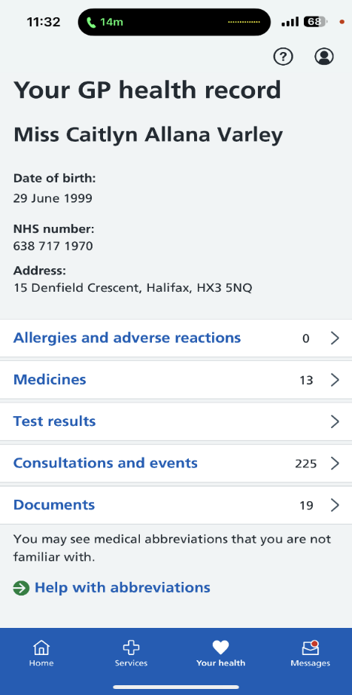

### Prescriptions

* + - * + A screenshot of a phone

          AI-generated content may be incorrect.With this feature you can view your current prescriptions, request repeats and nominate a pharmacy of your choice.

### Appointment bookings

* + - * + **A screenshot of a phone

          AI-generated content may be incorrect.**With this feature you can book, amend and cancel appointments.
        + Hospital referrals and appointments – view and manage hospital outpatient referrals and appointments.

### Messages and notifications

This feature allows you to send non-urgent enquiries to your GP and receive in app messages instead of letters and text messages.

### Linked profiles and proxy access

This feature allows you to manage care, book appointments or view medical info for someone you take care of, for example a child or dependant.

### Health choices

* **A screenshot of a medical survey

  AI-generated content may be incorrect.**Organ donation – this feature allows you to register your organ donation decision.
* Taking part in research

## **Upcoming and planned features**

* AI-powered Health Assistant – this upcoming feature will allow symptom checking and intelligent signposting to services.
* Self-Referral Services – with this feature you will have access to services such as mental health, musculoskeletal therapy, and podiatry without going through a GP.
* Wearable Tech Integration – this will allow you to sync data from fitness trackers and health devices.
* Hospital Appointment Booking – this feature allows you to self-book hospital app, view wait times and ratings, explore clinical trials.

## **Frequently Asked Questions**

### How do I download the app?

You can download the NHS App on your smartphone or tablet via the Google Play or Apple App Store.

You must be 13 or over to use the NHS App and you also need to be registered with a GP surgery in England or the Isle of Man.

### How do I register for/log in to the app?

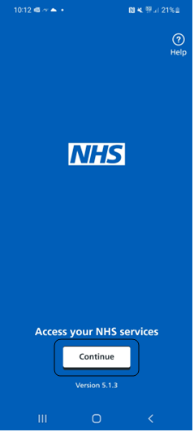Once you have downloaded the NHS App you should see an opening page like this -

Press continue and use the arrows to progress through the step-by-step introduction until you reach this page to enter your email address:

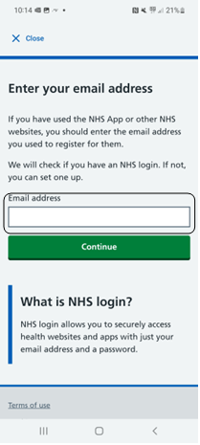Enter your email address, if you have a log in already it will ask for a password. If you have not registered, it will redirect you to a page to do so.

**To set up an NHS login you will need:**

* an email address (with more than 6 characters)
* a mobile phone or a landline number

To be able to use some services, you will also need to provide your:

* NHS number or your full name
* date of birth
* postcode

To access your health records or any personal information you will also need to provide high level proof of who you are. If your mobile phone number matches the one you have registered with your GP, we will use it to verify your identity. Otherwise, you will need to provide proof of identity.

This can be a:

* passport
* UK driving licence (full or provisional)
* Biometric Residence Permit (BRP)
* UK Residence Card, or EEA Biometric Residence Card (BRC) (including temporary pass)
* European driving licence (full)
* European national identity card

If you cannot provide a valid photo ID, you can use your registration details from your GP surgery.

These are:

* a Linkage Key (also known as Passphrase)
* an ODS Code (also known as Organisation Code or Surgery ID)
* an Account ID

You need to ask your GP surgery for these details.

**Then to log in you will need to:**

* Enter your email address.
* Create a password.
* Enter the security code we email to you.

For added security, you will need to set up Two-step verification by:

* Providing a mobile phone or landline number.
* Entering the 6-digit security code we send to this number.

To access some websites and apps, you may need to provide additional information and prove who you are. This is so we can connect you to your NHS record and protect your health information.

### How do I book appointments using the NHS App?

**To check for available GP appointments:**

1. Go to **Services**.

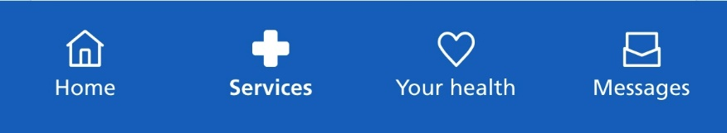

1. Select **Check for available GP appointments**

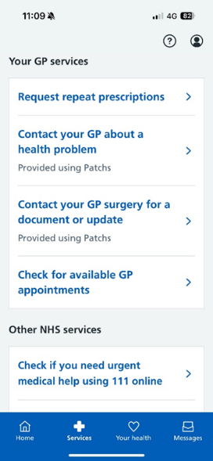

1. Select **Book a GP appointment**.

### I followed those steps, but it says there are no appointments available

 **If appointment booking is unavailable**

Your GP surgery may have switched off appointment booking. You can contact your surgery to book a GP appointment.

Depending on your GP surgery, you may have the option to **Contact your GP surgery about a health problem** on the **Services** page. This can lead to an appointment or other support from your GP surgery.

Your NHS App can show appointments that are available to book online at your surgery in the next 16 weeks.

**Your GP surgery decides how far in advance appointments are available to book.**

### What if I need a longer appointment?

Appointments are usually 10 minutes long. Some GP surgeries may offer longer appointments.

Depending on the type of appointment you need, you may be able to book a longer appointment.

To find out more about the types of appointments available and how they might suit your needs:

1. Go to **Services**.
2. Select **Check for available GP appointments**.
3. Select **Book a GP appointment**.
4. Select **Which types of appointment should I book?** to see any information that your GP surgery may have added.

### I have forgotten when my appointment is, can I check on the App?

To view upcoming and past GP appointments:

1. Go to the homepage or **Your health**.

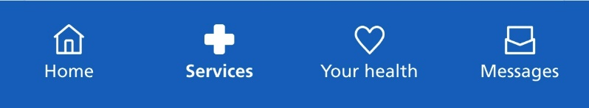

1. Select **Upcoming and past appointments**.

1. Select **GP surgery appointments**.

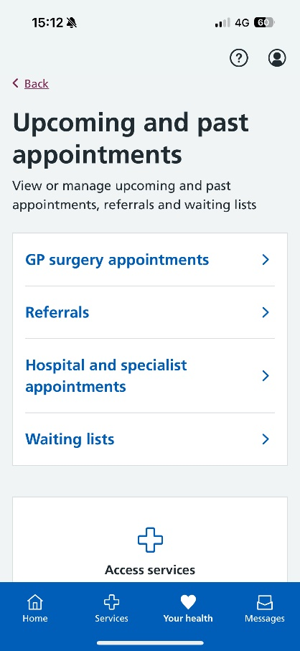

### I need to cancel my appointment; can I do this via the App?

When you are in your GP surgery appointments in the app, this will show your upcoming GP appointments. To cancel an appointment, you can find the appointment here and select **Cancel this appointment**.

**Your GP surgery may stop accepting online cancellations if it's too close to the appointment time. If you cannot cancel your appointment online, contact your surgery.**

### How do I view my medication and order prescriptions using the NHS app?

##### **Request a prescription**

To request a repeat prescription using the NHS App:

1. Go to the homepage or **Services**.A blue rectangle with white text

   AI-generated content may be incorrect.
2. Select **Request repeat prescriptions**.

##### **Requesting urgent repeat prescriptions**

If you need your medicine urgently, contact your GP surgery. If it's out of hours, go to [NHS 111 online](https://111.nhs.uk/) or call 111.

##### **Missing medicines you want to request**

You may not see a medicine listed if:

* it's not been prescribed for at least 6 months
* it was prescribed at a hospital or other secondary care centre
* it was prescribed at a time when you lived outside England
* your GP surgery does not currently offer repeat prescriptions online

If you cannot see a medicine you want to request, contact your GP surgery.

##### **If you're unable to request certain medicines**

You may not be able to request some medicines if:

* you need a medicine review
* it’s too soon to request your medicine after your previous request
* it’s a one-off course of medicine
* it's already been requested
* you have a repeat dispensing prescription

Contact your GP surgery to book a medicine review or to find out when you can next order your prescription.

If you have a repeat dispensing prescription, your GP will have already approved your medicine for a specific period. You do not need to request the medicine again.

##### **Viewing your requested medicines**

Your medicine request needs to be approved by the GP before it can be prepared by the pharmacy. You can view your **Requested medicines** to see when they've been approved.

Each medicine may be labelled:

* waiting GP approval
* approved by GP
* rejected by GP

Once the medicine has been approved, the request is automatically sent to the pharmacy if you have chosen one.

If the medicine you requested has been rejected and you want to know why, contact your GP surgery.

##### **If your prescription or medicine is showing as cancelled this may be because:**

* the treatment is no longer suitable for you
* the prescribed medicine may need to be changed

If you want to know why your medicine or prescription was cancelled, contact your GP surgery.

If you want to know why your medicine or prescription was cancelled by pharmacy, contact the pharmacy.

### How do I view my record including recent consultations?

You can use the NHS App or log in through the NHS website to access your GP health record. This is a record of your personal health information. It may include details about your health conditions and treatments you've had.

##### **Viewing your record**

You can view your record by logging in to the NHS App or the NHS website and selecting   
**GP health record** from the homepage.

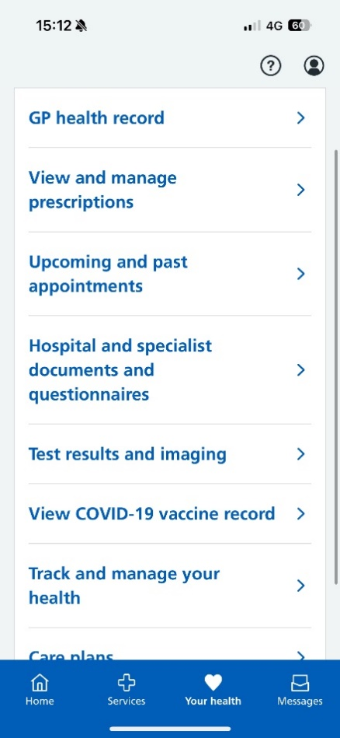

You can also find it in **Your health**.

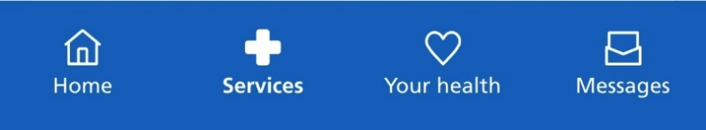

**Important: Protecting your privacy**

Your record may contain sensitive information. If someone is pressuring you for this information, contact your GP surgery immediately.

You can speak to your surgery if you would rather not have access to your health record in your NHS App.

##### **Asking for a more detailed record**

If you have access to your GP health record, you will be able to see your summary record as a minimum. This contains information about your medicines and allergies.

Most people will automatically be given access to more information added to their more detailed GP record from November 2023 onwards. This includes letters, test results and appointment notes. Some people may also have access to information added to their GP record before this date.

If you only have access to your summary record, you’ll see a message letting you know that you can request access to more information. You can contact your GP surgery and request access to your detailed coded record.

##### **If information is missing or incorrect**

If information in your GP health record is incorrect, contact your GP surgery. They can update personal information in your record, such as your address.

Contact your GP surgery if something is missing from your GP health record. It may be missing because you do not have access to all the information in your record. Ask them to give you access to your detailed coded record.

If the whole record is not yours, [contact the NHS App team](https://www.nhs.uk/contact-us/nhs-app-contact-us/) immediately.

### Can I view my COVID-19 vaccines in your record

Your GP health record cannot be used to prove your vaccine status when travelling abroad. You can use the [NHS COVID Pass service](https://www.nhs.uk/nhs-app/nhs-app-help-and-support/health-records-in-the-nhs-app/about-the-nhs-covid-pass-service/) to do this.

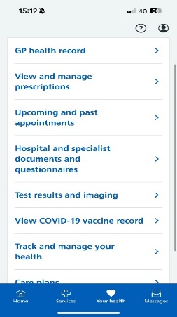

You can also view details of your vaccines using the [Check your COVID vaccine record](https://www.coronavirus-record.service.nhs.uk/) service.

If you’ve had the coronavirus (COVID-19) vaccine, you may be able to see it in your GP health record.

However, this will depend on:

* whether your GP has given you access to this information
* where you received your vaccine
* how the vaccination was recorded

It will usually appear in your GP health record within 48 hours. It may take longer if the vaccine needs to be added manually. If you cannot see your COVID-19 vaccine after 48 hours, make sure you have access to your detailed coded record.

### What is a Personal Health Record?

A personal health record stores information about your health and care online. Both you and health professionals who care for you can add information to it.

It’s different to your [GP health record](https://www.nhs.uk/nhs-app/nhs-app-help-and-support/health-records-in-the-nhs-app/gp-health-record/), which is a central record that your GP surgery manages. You can view your GP health record, but unlike a personal health record, you can’t add information to it.

Depending on your GP surgery or hospital, you might have access to personal health record services in the NHS App. This could include:

* hospital and specialist messages, appointments, documents and questionnaires
* useful links that health professionals (such as hospital staff) have shared with you
* care plans recording your choices about how you’re cared for
* records of your hospital medicines
* health symptom tracking
* options about how your records are shared with your health team
* a form to update your GP surgery about changes to your personal details
* forms to contact your GP about a health problem, or to request things like test results, fit notes (sick notes) or GP letters
* a form to join a patient participation group at your GP surgery

You can find out more in our [personal health record privacy policy](https://www.nhs.uk/nhs-app/nhs-app-legal-and-cookies/nhs-app-privacy-policy/personal-health-records/).

### How do I view my test results?

**Test results in your record**

You can see test results carried out by your GP surgery if you have access to your detailed coded record.

If you have access to your personal health record in your NHS App, you may be able to see hospital test results. See **PERSONAL HEALTH RECORD**.

If you have questions about test results in your GP health record, contact your GP surgery.

1. A blue background with white text

   AI-generated content may be incorrect.Go to **Your Health**
2. Go to **Test Results and imaging**

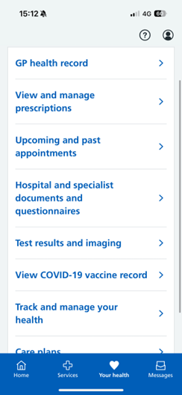

1. Choose between **GP or hospital ordered test results**

### How do I access messages sent to me by my practice?

The messaging services available in your NHS App depend on your GP surgery or healthcare providers.

You may be able to:

* view messages from your NHS healthcare services
* send messages to your GP surgery
* request advice and view responses from your GP surgery
* view and send messages between you and your healthcare provider (for example, from specialist doctors at a hospital)

You can also [turn on notifications](https://www.nhs.uk/nhs-app/nhs-app-help-and-support/nhs-app-account-and-settings/managing-nhs-app-notifications/) for the NHS App to find out about new messages. You cannot get notifications when accessing your NHS account through a web browser.

This service is a reliable and secure way to get information that you might usually get through text messages or letters.

**Messages are:**

* sent directly to you using your NHS number (instead of phone number or address), which means it is a more reliable way to reach you if your contact information is out of date at your GP surgery
* always from verified senders, such as your GP surgery and healthcare providers
* kept secure by the same technology that keeps your other information safe in the app

You may get messages through other ways, such as text messages, as well as through your NHS App.

##### **Request advice and view responses from your GP surgery**

If your GP surgery offers this service, you'll be able to answer questions online (sometimes called an online consultation) and get a response from your GP surgery. This will usually be a text message, phone call or message in your NHS App.

##### **Receive messages and updates from your specialist doctors**

You may be able to send and receive messages between you and health professionals. For example, specialist doctors at a hospital. Messages are sent or received through either:

* a personal health record provider
* an online consultation service provider

Although you access these messages in the NHS App, they are hosted by a supplier contracted by your healthcare provider. You'll often be taken to the supplier's system to log in and view any messages sent through this service.

##### **How to find messaging:**

1. Go to **Messages**.

1. A screenshot of a phone

   AI-generated content may be incorrect.A screenshot of a phone

   AI-generated content may be incorrect.Here you will see your Inbox options